Temporal trends in VV ECMO utilisation before and during the COVID-19 pandemic: an ELSO registry analysis
Supplementary Appendix

Ryan Ruiyang Ling, Kollengode Ramanthan, Ying Chen, Ryan P Barbaro, Kiran Shekar, Daniel Brodie, Graeme MacLaren

Table of contents
Supplementary methods 2
Figure S1. STROBE inclusion flowchart 4
Figure S2. Alluvial plot depicting reporting practices of centres across time periods 5
Figure S3. Trends in number of centres and centre volume across time periods stratified by ELSO chapter 6
Figure S4. Incidence rate ratios of VV ECMO cases over time. 6
Figure S5. Adjusted odds ratio of 90-day mortality stratified by annual volume 7
Figure S6. Standardised mortality ratios over time. 7
Table S1. Trends in centre characteristics over time 8
Table S2. Centre characteristics over time, stratified by ELSO chapter 8
Table S3. Demographics, centre, and pre-ECMO characteristics across the three time periods 9
Table S4. Arterial blood gas before and after ECMO initiation 10
Table S5. Ventilatory parameters before and after ECMO initiation, across time periods 11
Table S6. Pre-ECMO adjunctive therapies 12
Table S7. Adjusted mortality, median SMR, and odds of death at 90 days after ECMO initiation 12
Table S8. Complications while receiving ECMO 13

Supplementary methods
Data synthesis
We summarised patient demographics, centre characteristics, and clinical characteristics using the appropriate descriptive statistics. For center characteristics (number of centres and centre volumes), we repeated the analysis, stratifying the data based on ELSO chapter to better understand chapter-level changes in trends over time.

We used incidence rate ratios to better characterize the evolution of case volumes over time, which we derived by modelling a Poisson regression of the year of ECMO initiation against the number of ECMO cases per year. We then compared the number of cases in one year against the preceding year (for example, 2018 vs. 2017), which we graphically displayed in a non-linear fashion using restricted cubic splines with for knots.

To better understand trends in hospital mortality over time, we used a logistic regression model, to which we adjusted for the Respiratory ECMO Survival Prediction (RESP) score, and annual centre volumes. We also used g-computation to predict the adjusted probability of in-hospital mortality over time. Briefly, g-computation provides model-based estimates of population-average effects, as opposed to covariate-conditional estimates. As we hypothesized that centre volume may affect changes in outcomes over time (for example, that one might reasonably assume that a higher-volume centre might have more substantial reductions in mortality over time), we introduced a multiplicative interaction term between the year of ECMO initiation and centre volume, which we modelled as per prior literature (using 30 cases as a threshold for a high-volume centre). We estimated the odds of mortality in high and low-volume centres over time, which we graphically displayed in a non-linear fashion as described above. We conducted the analysis using RStudio 4.2.2.

To estimate standardized mortality ratios (SMRs), we derived the predicted mortality based on the RESP score. To obtain more granular estimates of mortality with each RESP score¹, we downloaded raster images of the RESP score against mortality in its initial publication. We then used a graph plot digitizer and calibrated the x- and y-axes as displayed in the curve, before deriving the corresponding y-coordinate (predicted survival) against each x-coordinate (RESP score). A screenshot of the process is shown below.
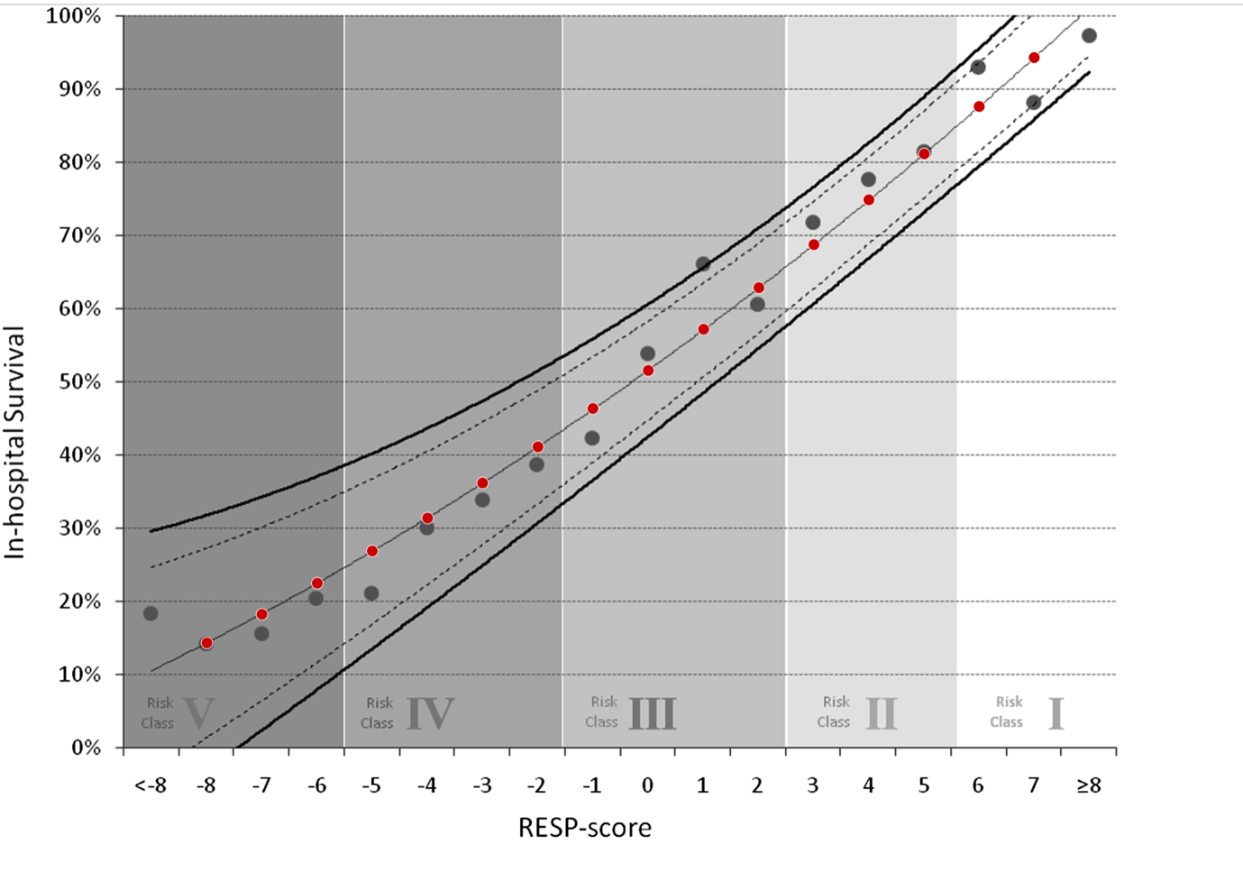

This methodology has been conducted exclusively in meta-analyses of reconstructed individual participant data^{2,3}, and we apply an iteration of one of the steps of this method. We then derived the centre’s SMR by dividing the actual mortality rate of the centre by the mean predicted mortality of that centre. In order to assess temporal trends, we also stratified the SMR in each centre by year of ECMO initiation, which we then plotted using a funnel plot against centre volumes on a logarithmic 10 scale.

References
1. Schmidt M, Bailey M, Sheldrake J, et al. Predicting survival after extracorporeal membrane oxygenation for severe acute respiratory failure. The Respiratory Extracorporeal Membrane Oxygenation Survival Prediction (RESP) score. Am J Respir Crit Care Med 2014;189(11):1374-82. (In eng). DOI: 10.1164/rccm.201311-2023OC.
2. Ling RR, Ramanathan K, Tan WQ, et al. Interleukin-6 Receptor Antagonists for Severe Coronavirus Disease 2019: A Meta-Analysis of Reconstructed Individual Participant Data from Randomised Controlled Trials. SSRN 2021 (http://dx.doi.org/10.2139/ssrn.3844782).
3. Low CJW, Ling RR, Lau M, et al. Mechanical circulatory support for cardiogenic shock: a network meta-analysis of randomized controlled trials and propensity score-matched studies. Intensive Care Med 2024;50(2):209-221. (In eng). DOI: 10.1007/s00134-023-07278-3.

Figure S1. STROBE inclusion flowchart
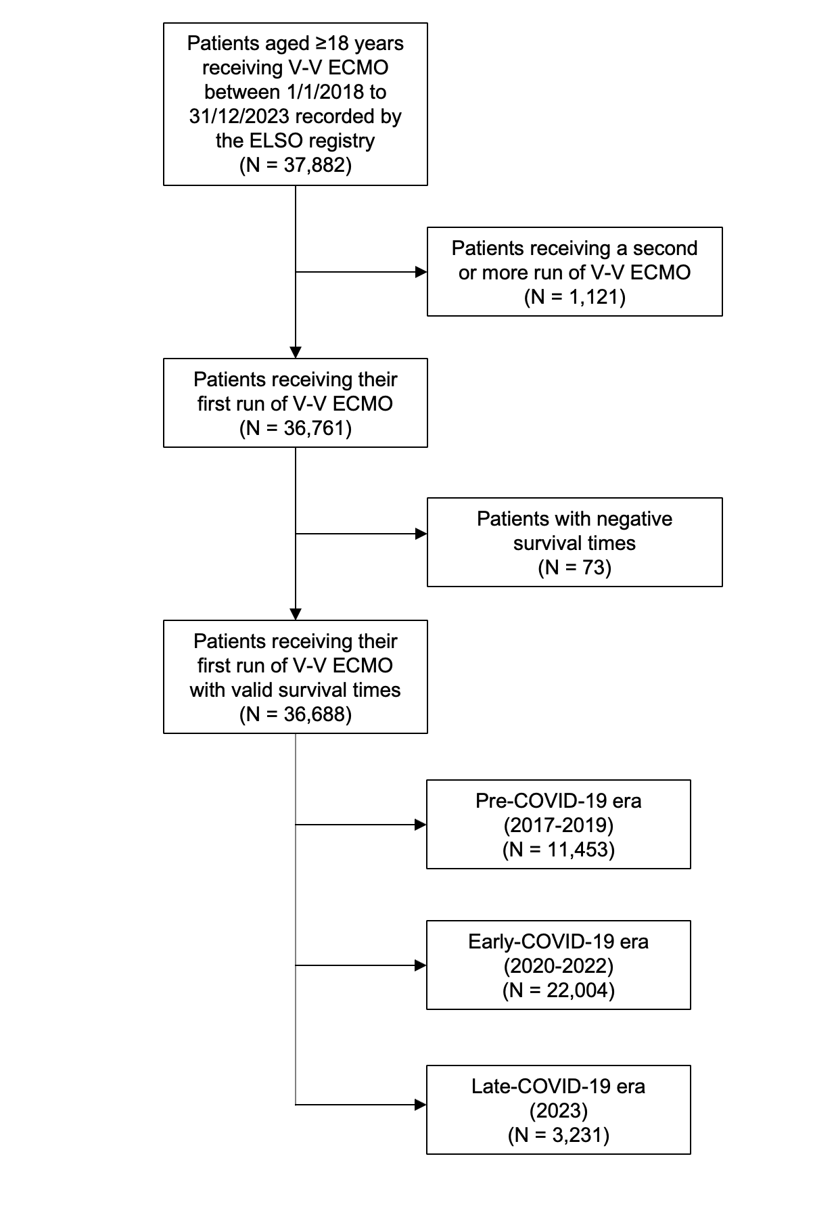

Figure S2. Alluvial plot depicting reporting practices of centres across time periods
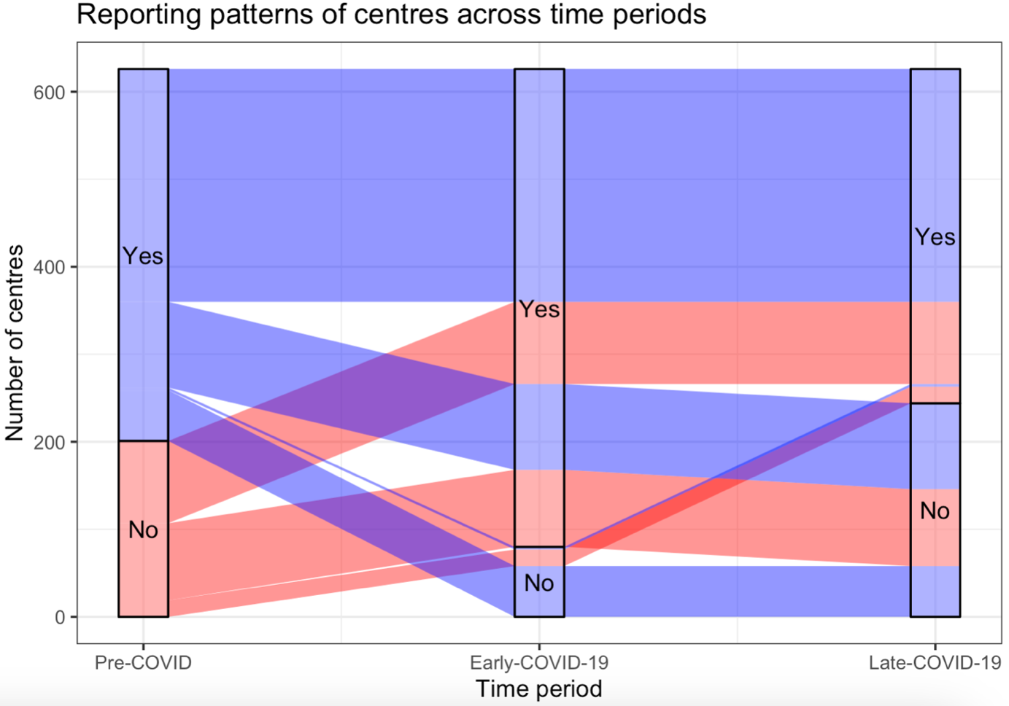
In the Pre-COVID-19 period, each centre can either report, or not report data to the ELSO registry. As time passes and we enter the early-COVID-19 period, there were 182 centres which started reporting data to the ELSO registry (transitioning from “No” to “Yes”), and 61 centres which stopped reporting data (transitioning from “Yes” to “No).

From the early-COVID-19 period to the late-COVID-19 period, an additional 22 centres started reporting data to the registry, and 186 centres stopped reporting data. Of the 182 centres which started reporting data during the early COVID-19 period, only 94 centres continued reporting data during the late-COVID-19 period.

Figure S3. Trends in number of centres and centre volume across time periods stratified by ELSO chapter
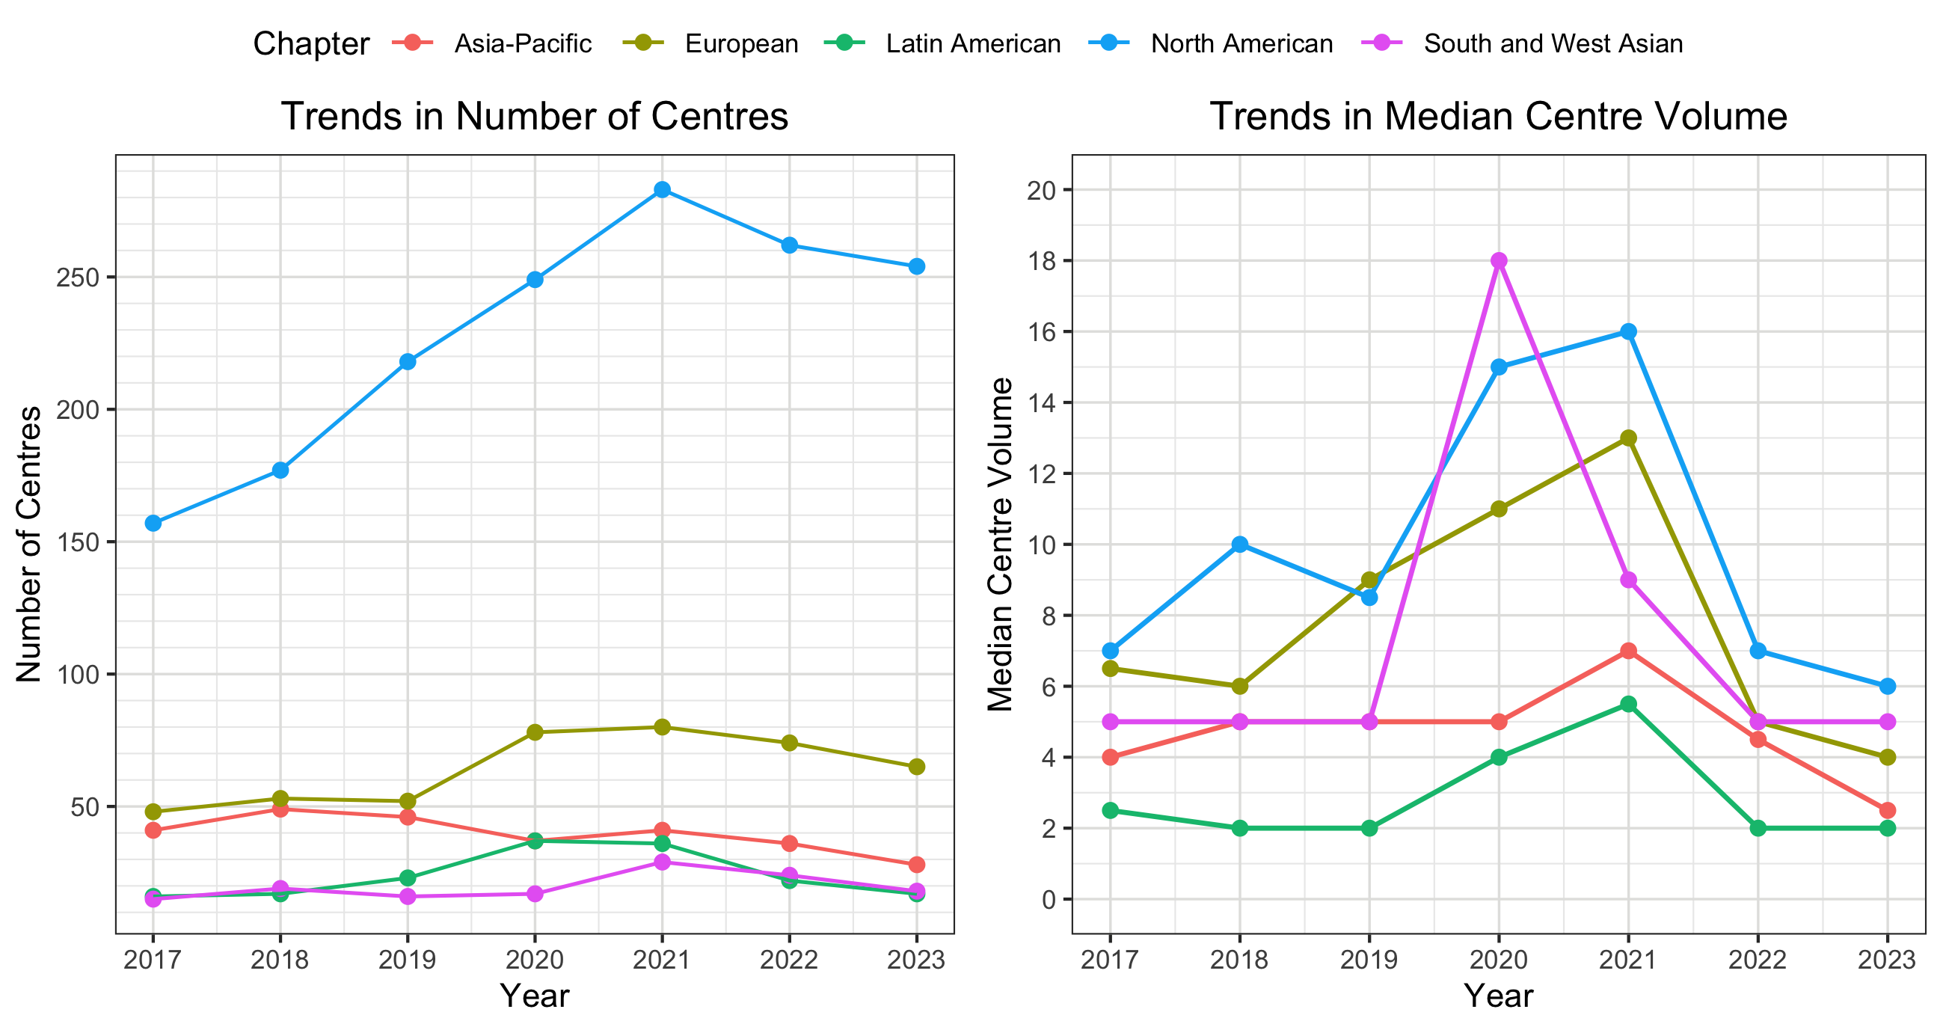

Figure S4. Incidence rate ratios of VV ECMO cases over time.
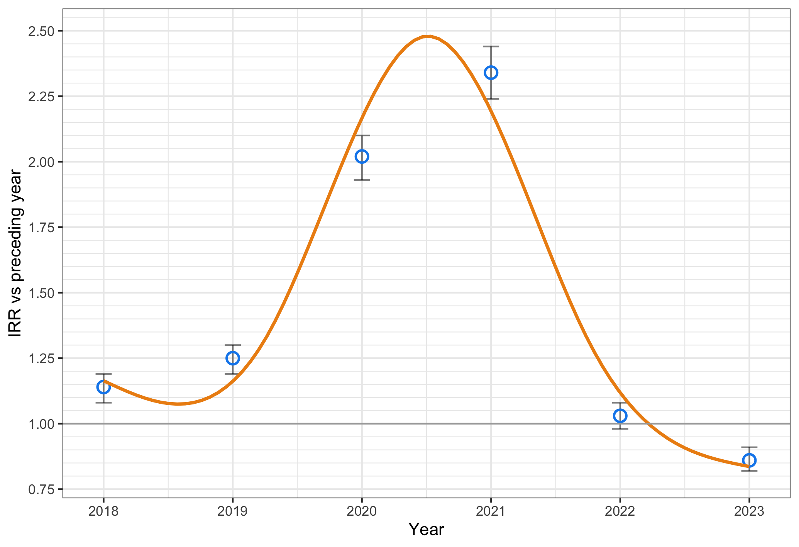

Figure S5. Adjusted odds ratio of 90-day mortality stratified by annual volume
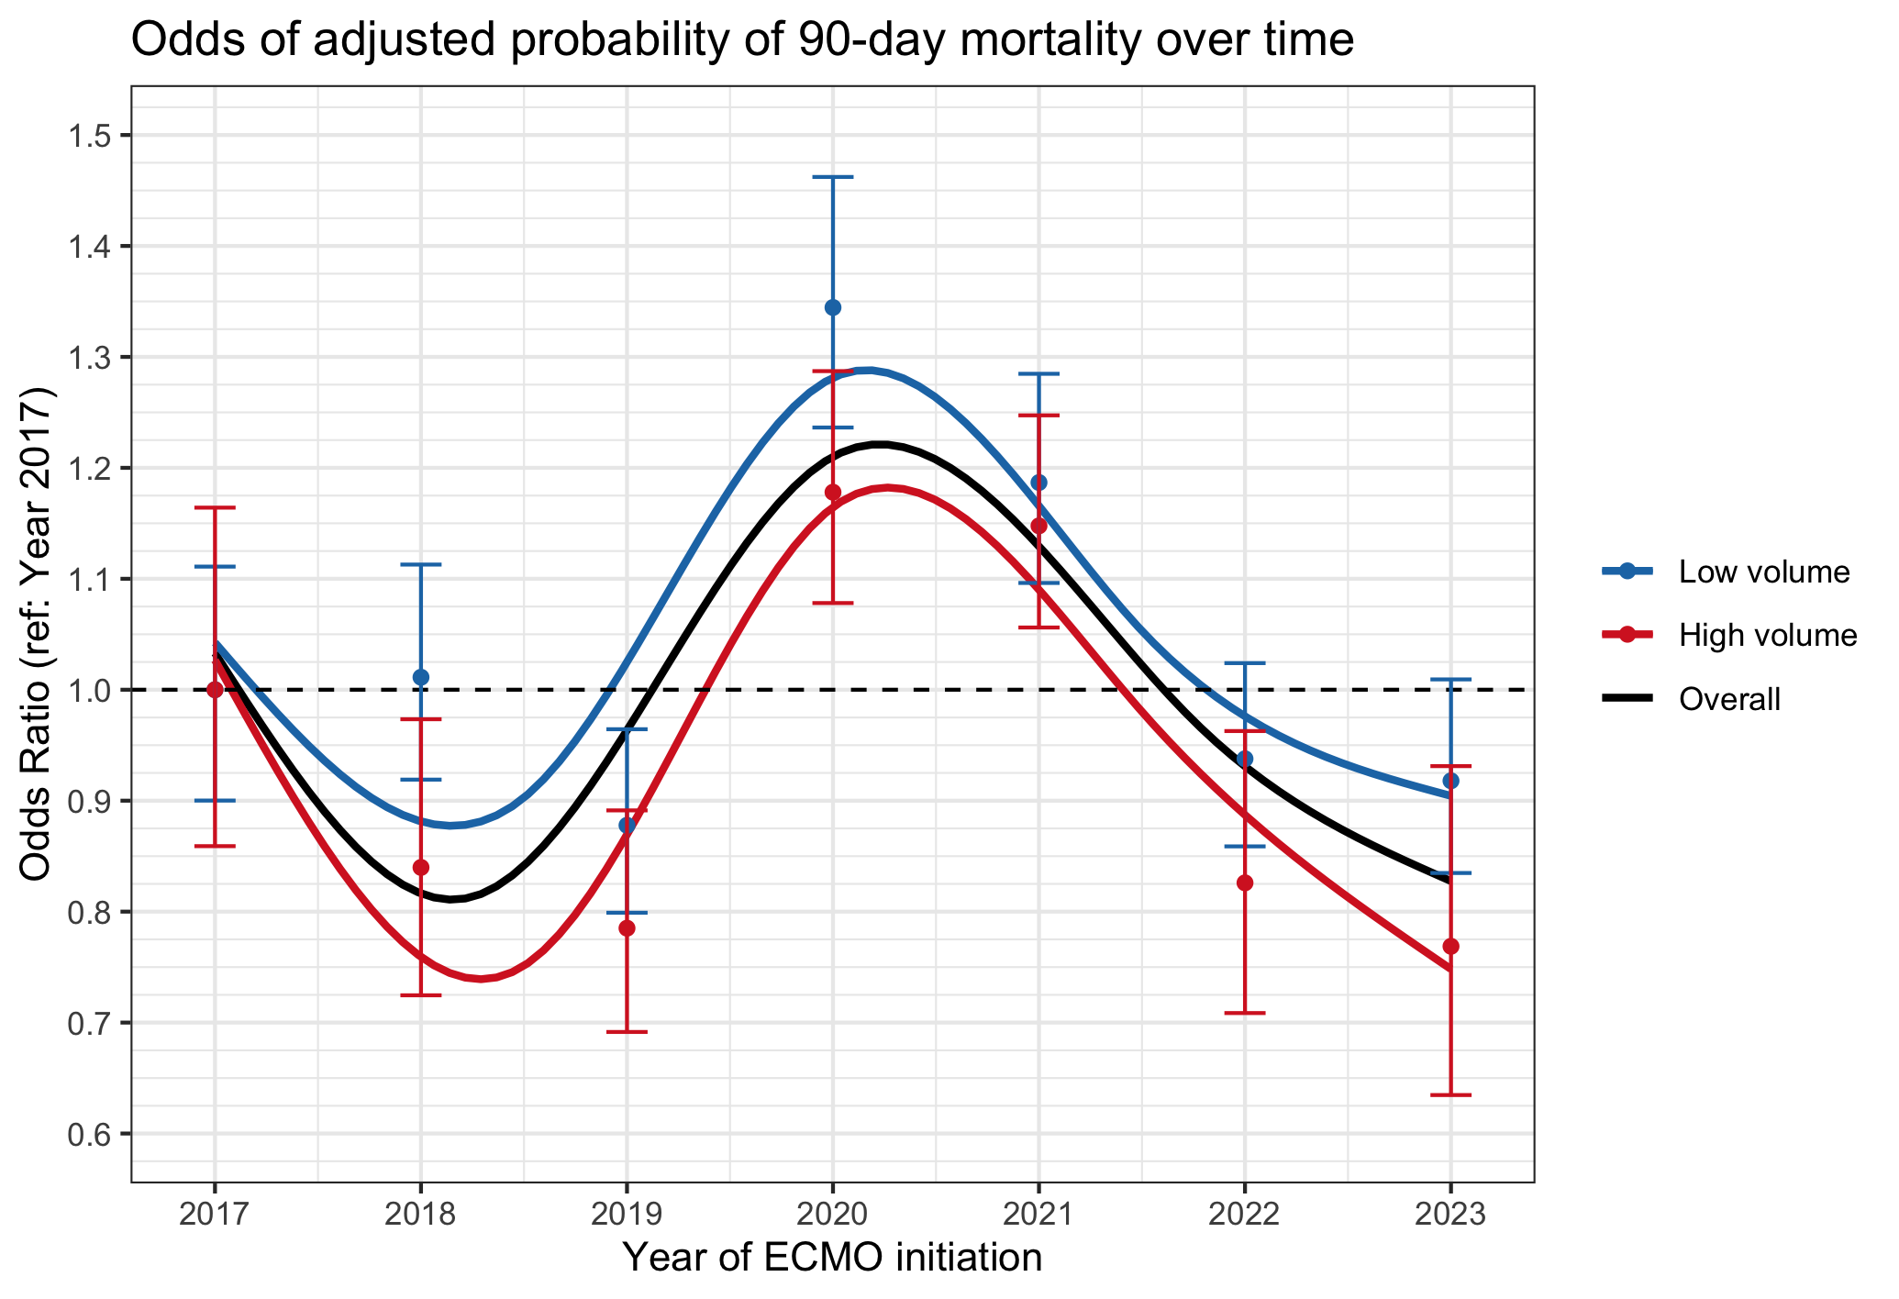

Figure S6. Standardised mortality ratios over time.
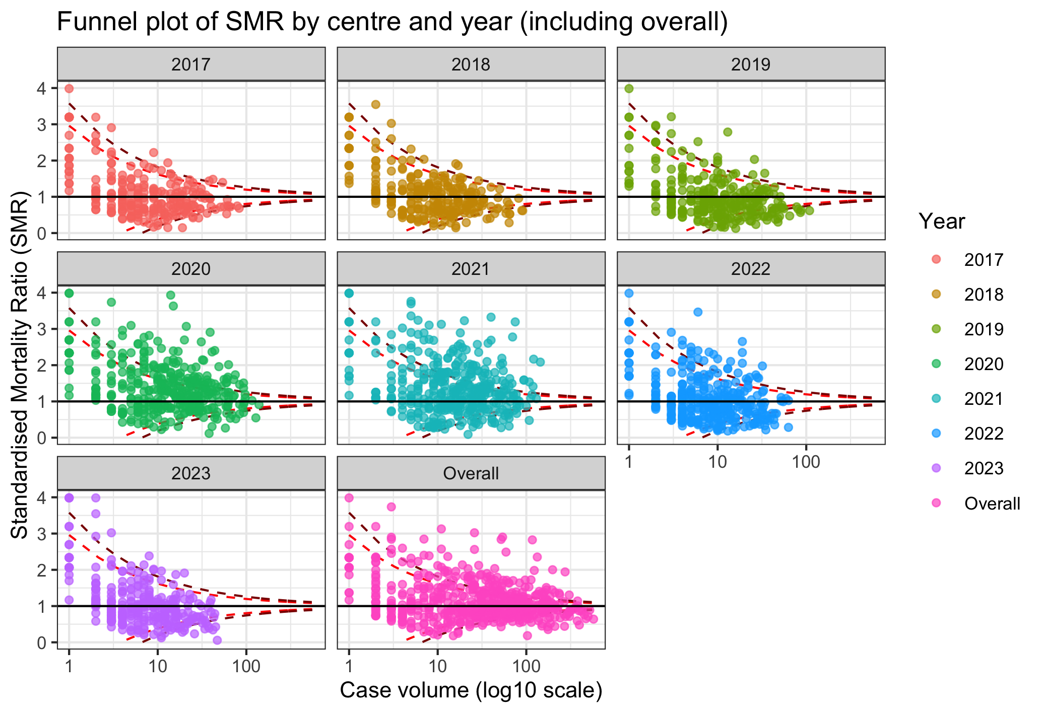

Table S1. Trends in centre characteristics over time
Year | 2017 | 2018 | 2019 | 2020 | 2021 | 2022 | 2023
Number of centres | 277 | 315 | 355 | 418 | 469 | 418 | 382
Centre volume | 6 (3-15) | 7 (3-16) | 7 (3-16) | 11 (4-26) | 13 (5-28) | 6 (3-13) | 5 (2-11)
Incidence rate ratio | Ref | 1.14 (1.08-1.19) | 1.25 (1.19-1.30) | 2.02 (1.93-2.10) | 2.34 (2.24-2.44) | 1.03 (0.98-1.08) | 0.86 (0.82-0.91)

Table S2. Centre characteristics over time, stratified by ELSO chapter
Era | 2017 | 2018 | 2019 | 2020 | 2021 | 2022 | 2023
Number of centres
Asia-Pacific | 41 | 49 | 46 | 37 | 41 | 36 | 28
North America | 157 | 177 | 218 | 249 | 283 | 262 | 254
Latin America | 16 | 17 | 23 | 37 | 36 | 22 | 17
Europe | 48 | 53 | 52 | 78 | 80 | 74 | 65
South West Asia & Africa | 15 | 19 | 16 | 17 | 29 | 24 | 18
Centre volume
Asia-Pacific | 4 (2-12) | 5 (2-11) | 5 (2-11) | 5 (4-11) | 7 (1-11) | 4.5 (2.75-8.5) | 2.5 (1-6)
North America | 7 (3-17) | 10 (4-17) | 8.5 (3.25-19) | 15 (6-30) | 16 (7-30) | 7 (4-14.75) | 6 (3-12)
Latin America | 2.5 (1-5) | 2 (2-5) | 2 (1-3.5) | 4 (1-13) | 5.5 (3-18) | 2 (1.25-5) | 2 (1-3)
Europe | 6.5 (3-12) | 6 (2-13) | 9 (3-16.5) | 11 (4-20.75) | 13 (4-29) | 5 (3-10) | 4 (2-9)
South West Asia & Africa | 5 (4-16.5) | 5 (3-12) | 5 (4-16.5) | 18 (6-49) | 9 (1-25) | 5 (3.75-10.75) | 5 (3.25-13.75)

Table S3. Demographics, centre, and pre-ECMO characteristics across the three time periods
Era | 2017 | 2018 | 2019 | 2020 | 2021 | 2022 | 2023
Participants | 3,219 | 3,779 | 4,545 | 8,104 | 9,721 | 4,179 | 3,231
Age (years) | 48.5 (36.4-58.7) | 49.0 (34.9-60.0) | 49.7 (35.8-60.7) | 49.5 (35.9-60.6) | 50.0 (39.2-58.8) | 46.2 (36.2-55.6) | 48.7 (35.0-59.8)
Weight | 89 (73-107) | 81 (68-100) | 84 (70-103) | 85 (70-105) | 90 (76-109) | 93 (79-110) | 85 (70-104)
Height | 170 (163-178) | 170 (163-178) | 170 (163-178) | 170 (163-178) | 170 (165-178) | 171 (164-179) | 170 (163-179)
BMI | 30.0 (25.5-35.8) | 27.8 (23.7-33.7) | 28.4 (24.2-34.5) | 29.2 (24.5-35.4) | 30.8 (26.3-36.6) | 31.4 (27.1-37.0) | 29.1 (24.7-34.9)
Female | 12,911 (35%) | 1,173 (39%) | 1,452 (38%) | 1,706 (38%) | 2,551 (31%) | 3,273 (34%) | 1,524 (37%)
Pre-ECMO/ECMO characteristics
Time from admission to intubation (hours) | 0 (-32 to 55) | 0 (-20 to 26) | 0 (-19 to 29) | 1 (-16 to 39) | 0 (-46 to 61) | -2 (-60 to 77) | 2 (-22 to 71)
Time from intubation to ECMO (hours) | 40 (9-121) | 26 (7-95) | 27 (7-94) | 26 (7-95) | 61 (14-139) | 58 (14-134) | 30 (8-115)
Duration of ECMO (days) | 10.3 (4.9-21.9) | 7.6 (3.7-13.8) | 7.6 (3.8-14.0) | 7.8 (4.0-14.8) | 12.9 (6.1-25.2) | 16.9 (7.5-33.1) | 8.8 (4.0-19.0)
COVID-19 addendum | NA | NA | NA | 4,880 (60%) | 7,177 (74%) | 948 (23%) | 180 (5.6%)

Table S4. Arterial blood gas before and after ECMO initiation
Era | 2017 | 2018 | 2019 | 2020 | 2021 | 2022 | 2023
Pre-ECMO arterial blood gas*
pH | 7.23 (7.13-7.33) | 7.24 (7.14-7.34) | 7.25 (7.16-7.34) | 7.28 (7.19-7.36) | 7.29 (7.20-7.37) | 7.27 (7.17-7.35) | 7.27 (7.17-7.35)
PaCO2 | 60 (48-77) | 59 (47-75) | 57 (46-72) | 60 (49-75) | 60 (49-75) | 59 (47-74) | 56 (45-70)
PaO2 | 66 (53-83) | 67 (54-86) | 67 (55-87) | 68 (56-83) | 66 (55-82) | 69 (57-93) | 70 (58-98)
PaO2/FiO2 ratio | 69 (54-98) | 71 (55-102) | 71 (56-103) | 72 (58-95) | 70 (56-91) | 73 (57-109) | 75 (59-117)
Post-ECMO arterial blood gas**
pH | 7.40 (7.35-7.44) | 7.40 (7.35-7.44) | 7.40 (7.35-7.44) | 7.40 (7.36-7.44) | 7.40 (7.36-7.44) | 7.40 (7.36-7.44) | 7.40 (7.36-7.44)
PaCO2 | 41 (37-46) | 41 (37-47) | 41 (37-47) | 44 (39-50) | 45 (40-52) | 43 (38-49) | 42 (37-47)
PaO2 | 83 (68-114) | 82 (67-109) | 83 (68-112) | 77 (65-98) | 75 (64-94) | 83 (68-112) | 88 (71-122)
PaO2/FiO2 ratio | 187 (127-273) | 165 (106-240) | 172 (109-253) | 158 (102-222) | 150 (100-210) | 173 (114-253) | 185 (122-268)
Abbreviations: PaO2: arterial partial pressure of oxygen, PaCO2: arterial partial pressure of carbon dioxide, FiO2: fraction of inspired oxygen
*Defined as the arterial blood gas closest to and not more than 6 hours before ECMO initiation
**Defined as the arterial blood gas drawn between 18 to 30 hours after ECMO initiation, closest to 24 hours after initiation of ECMO

Table S5. Ventilatory parameters before and after ECMO initiation, across time periods
Era | 2017 | 2018 | 2019 | 2020 | 2021 | 2022 | 2023
Pre-ECMO ventilatory parameters
Rate | 24 (18-30) | 24 (18-28) | 24 (18-28) | 25 (20-30) | 26 (20-30) | 24 (19-30) | 24 (18-28)
PIP | 34 (30-39) | 33 (28-38) | 33 (29-37) | 34 (30-38) | 33 (30-38) | 33 (29-38) | 33 (28-38)
PEEP | 12 (10-15) | 12 (10-16) | 12 (10-15) | 13.9 (10-16) | 12 (10-15) | 12 (8-14) | 10 (8-14)
Inflation pressure | 21 (16-26) | 20 (15-26) | 20 (16-25) | 20 (16-25) | 20 (16-25) | 21 (17-27) | 21 (16-26)
Post-ECMO ventilatory parameters
Rate | 12 (10-16) | 12 (10-16) | 12 (10-16) | 12 (10-16) | 12 (10-15) | 12 (10-16) | 12 (10-16)
PIP | 24 (20-28) | 25 (20-28) | 24 (20-28) | 25 (21-28) | 25 (21-28) | 24 (20-27) | 24 (20-27)
PEEP | 10 (8-12) | 10 (8-12) | 10 (8-12) | 10 (10-12) | 10 (10-12) | 10 (8-11) | 10 (8-10)
Inflation pressure | 14 (10-18) | 14 (10-18) | 14 (10-17) | 14 (10-17) | 13 (10-17) | 13 (10-17) | 14 (10-17)
Abbreviations: PIP: peak inspiratory pressure, PEEP: positive end-expiratory pressure
*Defined as the ventilatory parameters/settings closest to and not more than 6 hours before ECMO initiation
**Defined as the ventilatory parameters/settings between 18 to 30 hours after ECMO initiation, closest to 24 hours after initiation of ECMO

Table S6. Pre-ECMO adjunctive therapies
Era | 2017 | 2018 | 2019 | 2020 | 2021 | 2022 | 2023
Nitric oxide | 567 (24.1%) | 869 (27.2%) | 997 (25.3%) | 2,330 (31.6%) | 2,779 (31.2%) | 1,071 (29.1%) | 780 (27.6%)
Steroids | 474 (20.2%) | 680 (21.3%) | 778 (19.8%) | 2,143 (29.0%) | 4,245 (47.7%) | 1,196 (32.5%) | 793 (28.0%)
Bicarbonate | 352 (15.0%) | 498 (15.6%) | 618 (15.7%) | 735 (10.0%) | 630 (7.1%) | 504 (13.7%) | 441 (15.6%)
CVVH | 209 (8.9%) | 441 (13.8%) | 509 (12.9%) | 617 (8.4%) | 484 (5.4%) | 373 (10.1%) | 291 (10.3%)
Neuromuscular blockers | 1,213 (51.6%) | 1,923 (60.1%) | 2,418 (61.4%) | 5,193 (70.4%) | 6,265 (70.4%) | 2,212 (60.1%) | 1,524 (53.9%)
Vasodilator | 64 (2.7%) | 52 (1.6%) | 46 (1.2%) | 46 (0.6%) | 55 (0.6%) | 39 (1.1%) | 32 (1.1%)
Prone positioning | 67 (2.9%) | 546 (17.1%) | 742 (18.8%) | 3,318 (45.0%) | 4,375 (49.1%) | 858 (23.3%) | 489 (17.3%)
Abbreviations: THAM: tris-hydroxymethylaminomethane, CVVH: continuous venovenous hemofiltration

Table S7. Adjusted mortality, median SMR, and odds of death at 90 days after ECMO initiation
By Year | Mortality (95%-CI) | Median SMR (IQR) | Odds (95%-CI) of death
2017 | 37.8% (35.6%-40.0%) | 0.81 (0.53-1.23) | Reference
2018 | 36.7% (34.7%-38.7%) | 0.86 (0.52-1.24) | 0.95 (0.87-1.04)
2019 | 34.1% (32.2%-35.9%) | 0.73 (0.38-1.13) | 0.84 (0.77-0.92)
2020 | 43.4% (41.9%-45.0%) | 1.20 (0.77-1.68) | 1.27 (1.19-1.37)
2021 | 41.8% (40.4%-43.3%) | 1.13 (0.67-1.68) | 1.19 (1.123-1.27)
2022 | 35.5% (33.5%-37.4%) | 0.86 (0.42-1.25) | 0.90 (0.82-0.98)
2023 | 34.8% (32.7%-36.9%) | 0.79 (0.39-1.17) | 0.87 (0.79-0.96)

Table S8. Complications while receiving ECMO
Era | 2017 |  | 2018 |  | 2019 |  | 2020 |  | 2021 |  | 2022 |  | 2023
Era | Count | Rate* | Count | Rate | Count | Rate | Count | Rate | Count | Rate | Count | Rate | Count | Rate
Mechanical*** | 552 (30.9%) | 0.64 | 638 (31.3%) | 0.60 | 805 (34.2%) | 0.60 | 2,063 (41.6%) | 0.54 | 3,121 (50.2%) | 0.53 | 837 (36.5%) | 0.50 | 567 (33.9%) | 0.62
Haemorrhagic | 526 (29.5%) | 0.61 | 537 (26.4%) | 0.50 | 571 (24.2%) | 0.43 | 1,177 (23.7%) | 0.31 | 1,479 (23.8%) | 0.25 | 516 (22.5%) | 0.31 | 349 (20.8%) | 0.38
Renal | 909 (50.9%) | 1.05 | 1,123 (55.1%) | 1.05 | 1,354 (57.5%) | 1.01 | 2,491 (50.2%) | 0.66 | 2,773 (44.6%) | 0.47 | 1,176 (51.3%) | 0.70 | 901 (53.8%) | 0.98
Pulmonary | 220 (12.3%) | 0.25 | 289 (14.2%) | 0.27 | 292 (12.4%) | 0.22 | 937 (18.9%) | 0.25 | 1,437 (23.1%) | 0.24 | 429 (18.7%) | 0.25 | 265 (15.8%) | 0.29
Cardiovascular | 744 (41.7%) | 0.86 | 415 (20.4%) | 0.39 | 447 (19.0%) | 0.33 | 961 (19.4%) | 0.25 | 1,267 (20.4%) | 0.21 | 487 (21.2%) | 0.29 | 361 (21.6%) | 0.39
Metabolic | 417 (23.4%) | 0.48 | 171 (8.4%) | 0.16 | 246 (10.4%) | 0.18 | 663 (13.4%) | 0.17 | 876 (14.1%) | 0.15 | 371 (16.2%) | 0.22 | 259 (15.5%) | 0.28
Limb | 552 (30.9%) | 0.64 | 638 (31.3%) | 0.60 | 805 (34.2%) | 0.60 | 2,063 (41.6%) | 0.54 | 3,121 (50.2%) | 0.53 | 837 (36.5%) | 0.50 | 567 (33.9%) | 0.62
*Number of complications per 1000 hours of ECMO run.
**Complications have been grouped into broad categories in accordance with the ELSO registry.

